**Lab 08: Reflection and Refraction**

**Introduction:**

In this lab we will be looking at how things reflect off of concave ->) surfaces and convex surfaces ->(. We will be using two laws, the law of reflection and the law of refraction. The law of reflection states, the angle of the reflected beam makes with the normal angle is equal to the incident angle. This means that whatever angle the ray hits the concave surface at, then it will reflect at that angle also. The law of refraction states The incident ray, reflected ray and the normal, to the interface of any two given mediums; all lie in the same plane.

**Part I: Reflection - Concave and Convex Mirrors**

1. Calculate the image **position, height and orientation** for the following situation using the mirror equation and the magnification equation:

Mirror concave = focal point on same side as object

Focal length (f) = +3 cm (–3 on the simulation diagram)

Object distance (do) = +9 cm (–9 on the diagram)

Object height (ho) = +4 cm

Mirror equation: 1/f = 1/do + 1/di 🡪 1/3 = 1/9 + 1/di 🡪 (1/3 - 1/9)^-1 = di

Di = 4.5 cm

Real = image distance is positive.

Virtual = image distance is negative.

Magnification equation: M = hi/ho = -di/do 🡪 hi/4 = -4.5/9 🡪 hi = 4*4.5/9

Hi (image Height) = -2 cm

Inverted = height will be negative

2. In oPhysics: Position the focus and object on the simulation to match the initial conditions in question 1. Confirm that your answers were correct. If not, check your calculations. Reproduce the diagram below.

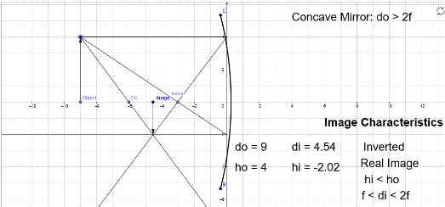

3. Calculate the image position, height and orientation for the following situation using the mirror equation and the magnification equation.

Mirror concave = focal point on same side as object

Focal length (f) = +3 cm

Object distance (do) = +11 cm

Object height (ho) = +4 cm

Mirror equation: 1/f = 1/do + 1/di 🡪 1/3 = 1/11 + 1/di 🡪 (1/3 - /1/11)^-1 = di

Di = 4.125 cm

Real = image distance is positive.

Virtual = image distance is negative.

Magnification equation: M = hi/ho = -di/do 🡪 hi/4 = -4.125/11 🡪 hi = 4*4.125/11

Hi (image Height) = -1.5 cm

Inverted = height will be negative

4. On the diagram, move the same object back 2 cm to the –11 mark. Confirm that your answers in question 3 were correct. If not, check your calculations. Reproduce the diagram below.

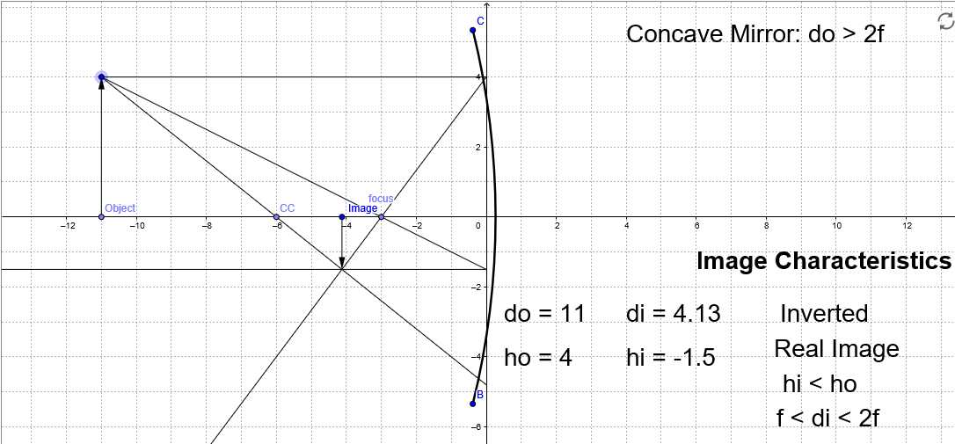

5. Did the image formed move toward or away from the focus compared to questions 1 and 2? Did the image get larger or smaller than before? Discuss.

It moved toward the focus and the image got smaller. It got smaller because the object is now farther away from the mirror.

6. Calculate the image position, height and orientation for the following situation using the mirror equation and the magnification equation.

Mirror concave = focal point on same side as object

Focal length (f) = +3 cm

Object distance (do) = +6 cm

Object height (ho) = +2 cm

Mirror equation: 1/f = 1/do + 1/di 🡪 1/3 = 1/6 + 1/di 🡪 (1/3 - 1/6)^-1 = di

Di = 6.00 cm

Real = image distance is positive.

Virtual = image distance is negative.

Magnification equation: M = hi/ho = -di/do 🡪 hi/2 = -6.0/6 🡪 hi = 2*6.00/6

Hi (image Height) = -2.00 cm

Inverted = height will be negative

7. Move the object to the center of curvature (6 cm), which is approximately 2f on a spherical concave mirror. Reduce the size to 2 cm as listed in question 6. Confirm that your answers were correct. If not, check your calculations. Reproduce the diagram here.

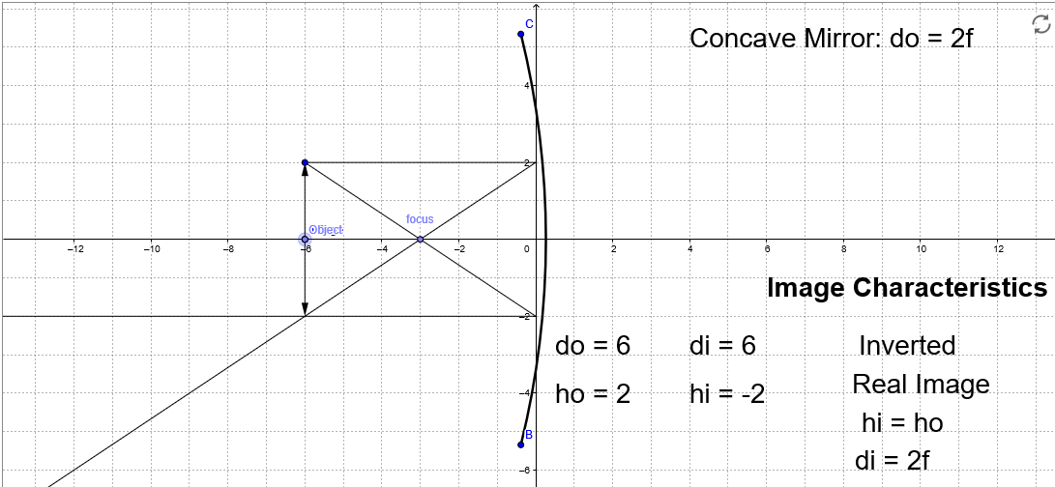

8. Calculate the image position, height and orientation for the following situation using the mirror equation and the magnification equation.

Mirror concave = focal point on same side as object

Focal length (f) = +3 cm

Object distance (do) = +3 cm (on the focal point)

Object height (ho) = +2 cm

Mirror equation: 1/f = 1/do + 1/di 🡪 1/3 = 1/3 + 1/di 🡪 (1/3 - 1/3)^-1 = di

Di = 0 cm

Real = image distance is positive.

Virtual = image distance is negative.

Magnification equation: M = hi/ho = -di/do 🡪 hi/2 = 0/3 🡪 hi = 2*0/3

Hi (image Height) = 0cm

No image will display

9. Move the object to the focal point (3 cm), which is the distance f on a spherical concave mirror. Keep the height at 2 cm as listed in question 8. Confirm that your answers were correct. If not, check your calculations. Reproduce the diagram here.

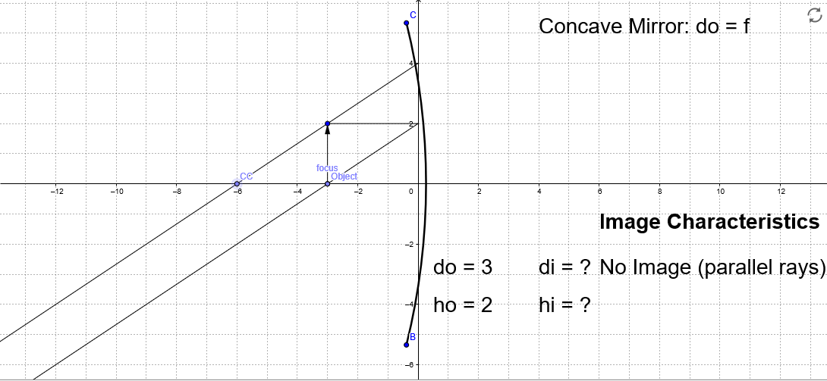

10. Calculate the image position, height and orientation for the following situation using the mirror equation and the magnification equation.

Mirror concave = focal point on same side as object

Focal length (f) = 3 cm

Object distance (do) = 2 cm (–2 on this diagram)

Object height (ho) = +2 cm

Mirror equation: 1/f = 1/do + 1/di 🡪 1/3 = 1/2 + 1/di 🡪 (1/3 - 1/2)^-1 = di

Di = -6.00 cm

Real = image distance is positive.

Virtual = image distance is negative.

Magnification equation: M = hi/ho = -di/do 🡪 hi/2 = -6.0/2 🡪 hi = 2*6.00/2

Hi (image Height) = 6.00 cm

Upright = height will be positive

Virtual image

11. Move the object to the 2 cm mark, which is inside the focal distance on this spherical concave mirror. Keep the height at 2 cm as listed in question 10. Confirm that your answers were correct. If not, check your calculations. Reproduce the diagram here.

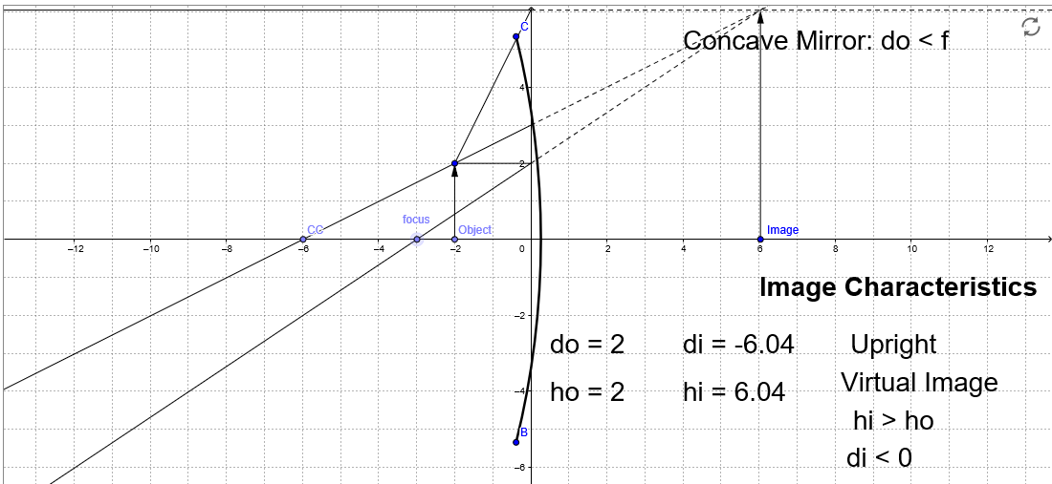

12. Is the image real or virtual when the object is inside the focal length?

The image is virtual when the object is between the mirror and the focus point.

**We will now assume we have a *convex* mirror in which the object position is a positive distance, but the focus is *behind the mirror in virtual space*. You will drag the object to the right side of the mirror.**

13. Calculate the image position, height and orientation for the following situation using the mirror equation and the magnification equation.

Mirror convex = focal point on the opposite side compared to the object

Focal length (f) = –3 cm (–3 on the diagram). Include minus in calculations.

Object distance (do) = +6 cm (+6 on the diagram)

Object height (ho) = +5 cm

Mirror equation: 1/f = 1/do + 1/di 🡪 1/-3 = 1/5 + 1/di 🡪 (1/-3 - 1/5)^-1 = di

Di = -1.875cm

Magnification equation: M = hi/ho = -di/do 🡪 hi/2 = -1.875/2 🡪 hi = 2*1.875/2

Hi (image Height) = 1.875 cm

Upright = height will be positive

Virtual image

14. Position the object on the simulation to match the conditions as listed in question 13. Confirm that your answers were correct. If not, check your calculations. Reproduce the diagram here.

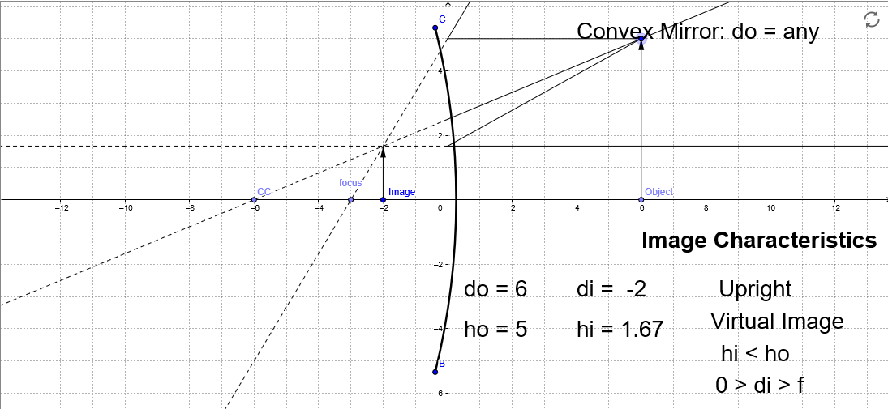

15. Move the object around to different positions on the right side of the mirror. Is the image produced ever real?

No its always virtual, a convex mirror will increase the angle of reflection and never be able to show a real image.

16. Is the image produced ever larger than the object?

No, it will always be smaller because of the extreme angle change of the reflection.

**Part II: Refraction**

1. Air ---> Water

|  |  |  |  |
| --- | --- | --- | --- |
| **Top Material:** | Air | **Index of Refraction:** | 1.00 |
| **Bottom Material:** | Water | **Index of Refraction:** | 1.33 |

|  |  |  |
| --- | --- | --- |
| **Incident Angle (you choose)** | **Reflected Angle** | **Refracted Angle** |
| 60 | 60 | 40 |
| 75 | 75 | 45 |

1. Air ---> Glass

|  |  |  |  |
| --- | --- | --- | --- |
| **Top Material:** | Air | **Index of Refraction:** | 1.00 |
| **Bottom Material:** | Glass | **Index of Refraction:** | 1.50 |

|  |  |  |
| --- | --- | --- |
| **Incident Angle (you choose)** | **Reflected Angle** | **Refracted Angle** |
| 75 | 75 | 40 |
| 60 | 60 | 35 |

1. Water ---> Glass

|  |  |  |  |
| --- | --- | --- | --- |
| **Top Material:** | Water | **Index of Refraction:** | 1.33 |
| **Bottom Material:** | Glass | **Index of Refraction:** | 1.50 |

|  |  |  |
| --- | --- | --- |
| **Incident Angle (you choose)** | **Reflected Angle** | **Refracted Angle** |
| 60 | 60 | 50 |
| 80 | 80 | 60 |

1. Water ---> Air

|  |  |  |  |
| --- | --- | --- | --- |
| **Top Material:** | Water | **Index of Refraction:** | 1.33 |
| **Bottom Material:** | Air | **Index of Refraction:** | 1.00 |

|  |  |  |
| --- | --- | --- |
| **Incident Angle (you choose)** | **Reflected Angle** | **Refracted Angle** |
| 60 | 60 | 0 |
| 75 | 75 | 0 |

1. Glass ---> Air

|  |  |  |  |
| --- | --- | --- | --- |
| **Top Material:** | Glass | **Index of Refraction:** | 1.50 |
| **Bottom Material:** | Air | **Index of Refraction:** | 1.00 |

|  |  |  |
| --- | --- | --- |
| **Incident Angle (you choose)** | **Reflected Angle** | **Refracted Angle** |
| 60 | 60 | 0 |
| 75 | 75 | 0 |

1. Glass ---> Water

|  |  |  |  |
| --- | --- | --- | --- |
| **Top Material:** | Glass | **Index of Refraction:** | 1.50 |
| **Bottom Material:** | Water | **Index of Refraction:** | 1.33 |

|  |  |  |
| --- | --- | --- |
| **Incident Angle (you choose)** | **Reflected Angle** | **Refracted Angle** |
| 60 | 60 | 75 |
| 80 | 80 | 0 |

1. Based on your data in the data tables, what patterns do you observe? Write at least three summary statements.

Light does not bend if the angle is 50 degrees or greater.

Glass bends the light more than water and more than air.

Light only reflects when the materials are different.

1. Now click on Prisms at the bottom. Turn on the laser. Drag the triangle prism into the path of the laser.   
   Click on the Normal button on the bottom right.   
   Draw the light rays, prism, and normal for your configuration.

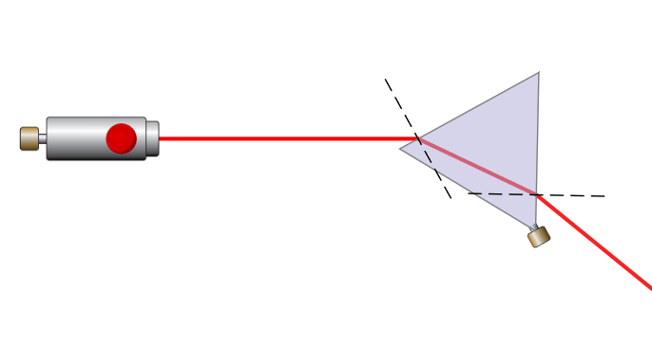

1. Change the light to white light. Rotate the prism until the light that comes out the other side of the prism is separated into the color spectrum. Draw your configuration indicating where the red and blue light is.

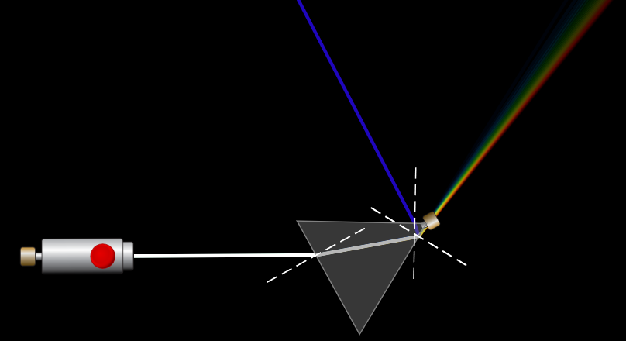

1. What color of light refracts more when moving through the prism?

Blues

1. Now remove the prism and drag the convex lens (rounded on the left side, flat on the right side) into the path of the laser. Select the multiple beam laser. Center the laser on the surface of the rounded side of the lens. Draw the lens and light rays.

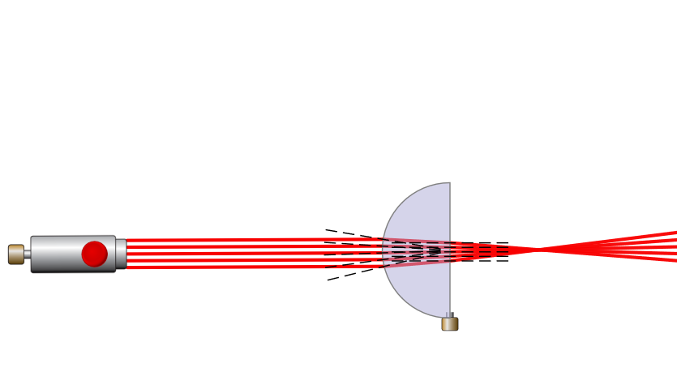

1. Now remove the convex lens and replace it with the concave lens (curved inward on the left side, flat on the right side). Draw the lens and light rays.

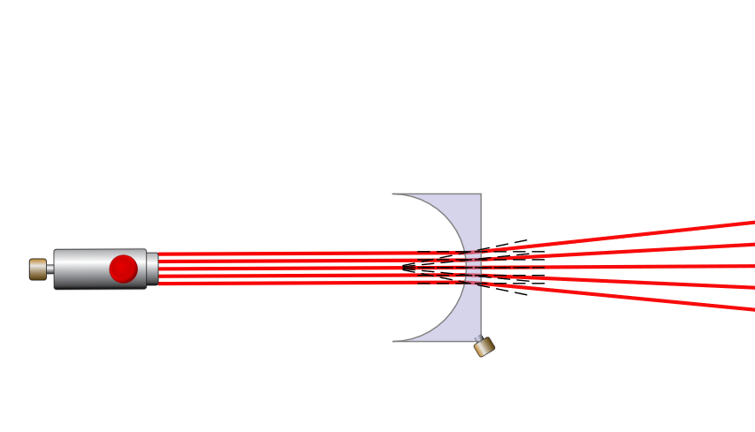

**Conclusion (for both Part I and Part II:**

We looked at how light reflects of different surfaces depending on the material and angle.

Concave can have a real or virtual image when the object is on the same side as the focal point. The convex cannot, it will always be a virtual image. The convex will show the image smaller and the concave will show the image as larger than the object.

We used to the laws of reflection and law of refraction to mathematically find the di, do, hi and ho. .